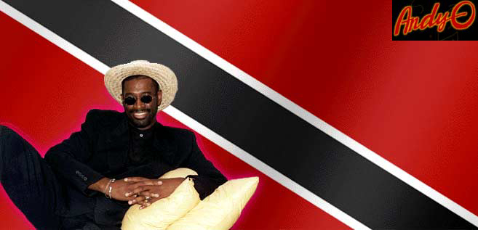
From the city of Port-of Spain on the island of Trinidad comes a singer and songwriter whose love for music can be traced back to his childhood days as a pan player in steel orchestras. Against the wishes of his parents, Andy-O began playing steel drums at the age of 16. The glamour of the Savannah stage at Carnival time captured this young boy's heart and he hoped that some day he would perform on the same stage that had hosted some of the world's greatest calypso artists. By the time Andy was 18, he had played on the Savannah stage with such steel orchestra greats as Huggins Pandemonium, Coca Cola Silverstars and Vat 19 Tripolians.
Andy moved to the United States in 1975 and settled in Bellingham, Washington. Andy's first band in the U.S. was an eight piece reggae/ska band called the Kooks. After playing local clubs for a few years, the band separated and Andy formed his next band called Andy O & The Youth All Stars. The All Stars, which consisted of mainly Western Washington University students, disbanded after six months when several members graduated and left town.
In 1985 Andy started a third band called Almighty Dread, a five piece reggae band that evolved and changed its name to Jumbalassy. After a very successful six years as lead vocalist and songwriter for the band, Andy decided to go solo. In August of 1991 Andy-O was formed to bring his soca-calypso-reggae sounds to crowded dance floors at local clubs, wedding receptions, fraternities, corporate parties and charity benefits. The Andy-O band is composed of eight musicians, featuring one of the hottest horn sections in the Pacific Northwest. Together they create sweet Caribbean sounds that dare the feet not to dance.
In 1992, the first single, Searchin..., was nominated for best world-music recording at the NAMA Awards. Also in 1992 he recorded his first CD, As Long As It Takes, with the band. Many of the songs on this CD have become crowd favorites and are requested by the audience at almost every show.
Getting Closer is the third solo release from Andy-O. This excitement-packed album is full of Andy's original compositions, an assortment of ballads, reggae, soca and calypso music.
The current band brings together musicians with a wealth of musical backgrounds from all over the world. Andy-O and the Calypso Orchestra continues to be one of Seattle's favorite bands.
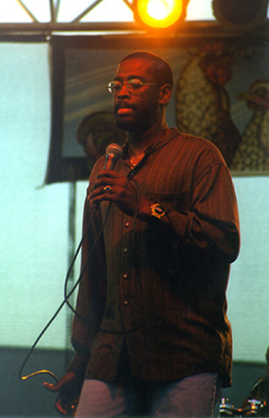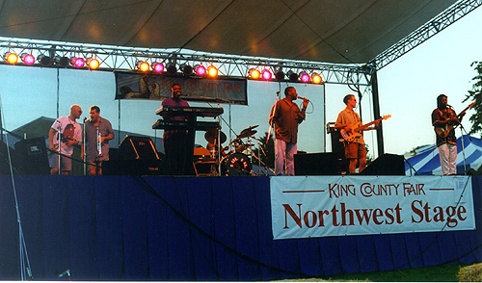

Link for audio files:
http://www.seeleymusic.com/Andy%20O%20-%20Party%20Girl.zip


Kevin Seeley
21424 NE 165th St
Woodinville, WA. 98077
206-465-1988

