Cliff Colon – Trio, Quartet and Quintet 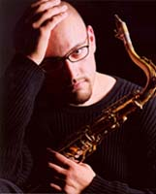
In a jazz community populated with remarkable tenor saxophonists, Cliff Colón's raw
expressiveness and ability to channel the purest of emotions into each note, sets him apart from the pack. A native of the Pacific Northwest, Colón commenced his musical exploration at the age of 10, later developing into an integral element in the music scene throughout Western Washington. His proficiency, and unabashed expression, has aided him in becoming a definite leader, innovative soloist, and an in demand sideman and instructor.Colón's style has been profoundly influenced by such saxophone legends as John Coltrane, Branford Marsalis, Pete Christlieb, and Michael Brecker. While dedicated to his career, Colón is also committed to educating the next generation of saxophonists, by conducting clinics, master classes, and private lessons.
Still in his twenties, Colón has merely scratched the surface of the long and promising musical career that lies ahead. His time as being regarded as only a prominent Northwest musician is limited, as he is working on branching out into the national music scene.

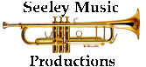
Kevin Seeley
21424 NE 165th St
Woodinville, WA. 98077
206-465-1988

