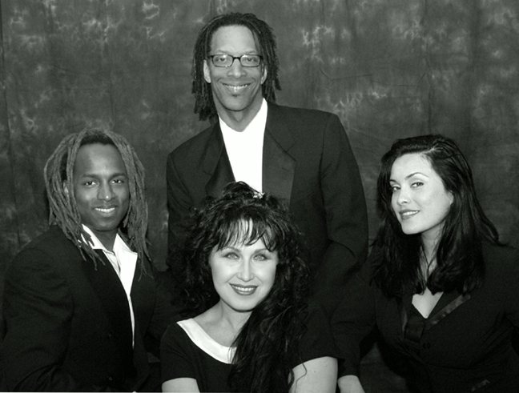
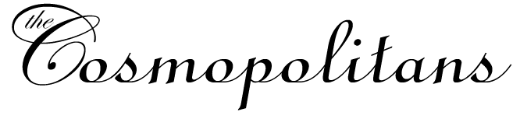
A premiere MoTown Revue comprised of four vocalists, rhythm section and two horns, The Cosmopolitans are sure to be a hit. Whether you want classic MoTown hits, Dance and Party music, Rock and Roll or Jazz, the Cosmopolitans can do it all. For tight budgets, the Cosmopolitans can also scale WAY back to a three piece.

Repertoire Motown
The Four Tops Reach Out (I’ll Be There)
I Can’t Help Myself (Sugar Pie Honey Bunch)
Marvin Gaye Ain’t No Mountain
Ain’t Nothin Like The Real Thing Baby
Got To Give it Up
Let’s Get it On
How Sweet it Is
Grapevine
Mercy Mercy Me
What’s Goin On
Smokey Robinson I Second That Emotion
Tears of a Clown
Shop Around
Supremes Where Did Our Love Go
Baby Love
Come See About Me
Stop! in the Name of Love
Back in My Arms Again
Heaven Must Have Sent You
Someday We’ll Be Together
The Temptations Ain’t Too Proud To Beg
Get Ready
Just My Imagination
My Girl
Papa Was a Rolling Stone
The Way You Do The Things You Do
Stevie Wonder Uptight
MyCherie Amour
Signed, Sealed, Delivered
Superstition
Don’t You Worry ‘Bout a Thing
Boogie On Reggae Woman
James Brown Get Up Offa That Thing
Papa’s Got a Brand New Bag
Aretha Franklin Respect
Natural Woman
Chain of Fools
Since You’ve Been Gone
Rock Steady
See Saw
The Isley Brothers For the Love of You
It’s Your Thing
Fight the Power
Gladys Knight & The Pips Midnight Train to Georgia
Spinners I’ll Be Around
Could It Be I’m Falling In Love
Then Came You
Martha Reeves & The Vandellas Heatwave
Dancin in The Streets
The Marvellettes Please Mr. Postman
Mary Wells My Guy
Wilson Pickett Midnight Hour
99 & ½ Won’t Do
Land of 1,000 Dances
Mustang Sally
The Jackson Five I Want You Back
ABC
The Love You Save
I’ll Be There
Shake Your Body
Sam & Dave Hold On I’m Comin’
Wrap It Up
Rick James Superfreak
You And I
Give it to Me Baby
Commodores Brick House
Slippery When Wet
Parliament Flashlight
Ohio Players Love Rollercoaster
Fire 5th Dimension Wedding Bell Blues
Aquarius/ Let the Sunshine In
O Jays Used To Be My Girl
Love Train
Backstabbers
Al Green Let’s Stay Together
Natalie Cole This Will Be (An Everlasting Love)
Pink Cadillac
Unforgettable
Jean Knight Mr. Big Stuff
Disco / Party Tunes
Taste of Honey Boogie Oogie Oogie
The Trammps Disco Inferno
K.C. & The Sunshine Band Get Down Tonight
Rose Royce Car Wash
Carl Carlton Bad Mamma Jamma
Wild Cherry Play That Funky Music
Michael Jackson Billie Jean
Rock With You
Don’t Stop ‘til You Get Enough
Chic Good Times
Dance Dance Dance
Le Freak
GQ Disco Nights
Thelma Houston Don’t Leave Me This Way
Bee Gees More Than a Woman
Night Fever
Yvonne Elliman If I Can’t Have You
Abba Dancing Queen
McFadden & Whitehead Ain’t No Stoppin’ Us Now
Gloria Gaynor I Will Survive
LaBelle Lady Marmalade
Donna Summer Last Dance
B-52’s Love Shack
Confunkshun Ffun
Boz Scaggs Lowdown
Richie Valens La Bamba
Earth Wind and Fire September
Let’s Groove
Shining Star
Average White Band Pick Up The Pieces
Cut The Cake
Buster Poindexter Hot Hot Hot
Ricky Martin La Vida Loca
Rock Tunes
AC/DC You Shook Me All Night Long
Aerosmith Walk This Way
Led Zeppelin Rock & Roll
No Doubt Just a Girl
Huey Lewis & The News Heart of Rock & Roll
The Troggs Wild Thing
Lynard Skynard Sweet Home Alabama
The Rascals Good Lovin’
Steppenwolf Magic Carpet Ride
Spencer Davis Group Gimme Some Lovin’
Loggins & Messina Your Mama Don’t Dance
The Romantics What I Like About You
Chuck Berry Roll Over Beethoven
Johnny B. Goode
Jerry Lee Lewis Great Balls of Fire
Beatles Twist & Shout
Saw Her Standing There
Drive My Car
Birthday
Van Morrison Brown Eyed Girl
Moondance
Rolling Stones Jumpin Jack Flash
Brown Sugar
Honky Tonk Woman
Satisfaction
Tommy James & The Shondells Mony, Mony
Elvis Presley Don’t Be Cruel
Jailhouse Rock
Bachman-Turner Overdrive Takin’ Care of Business
The Kinks All Day, All Night
Swing Tunes
In The Mood
Swing Swing Swing
Jump Jive & Wail
Boogie Woogie Bugle Boy
Jazz / Easy Listening / Ballads
Masquerade
The Good Life
You’d Be So Nice To Come Home To
My Funny Valentine
On Green Dolphin Street
‘Round Midnight
Embraceable You
Fly Me To the Moon
The Look of Love
The Girl from Ipanema
Route 66 Satin Doll
Blue Bossa Wave
That’s the Way Love Goes
What a Wonderful WOrld
When Sunny Gets Blue
You Send Me
Walk On By
Them There Eyes
Get Here
Saving All My Love for You
Smooth Operator
Sweet Love
Through The Fire
Where Is The Love
Breezin
Take The A Train
All of Me Affirmation
Summertime
Sunshine of My Life

Several Audio demos are available at:
http://www.thecosmopolitans.net/sounds.html


Kevin Seeley
21424 NE 165th St
Woodinville, WA. 98077
206-465-1988

