Mirage and the Bad Ass Brass is a smoking 7 piece horn band from the Everett, Washington Area. They pull from many years of performance and music business experience to create a diversified song list. Performing a mix of Classic Rock, R+B, Blues, Funk and Soul, the band covers a wide range of audience tastes.

The “Boys in the Band”

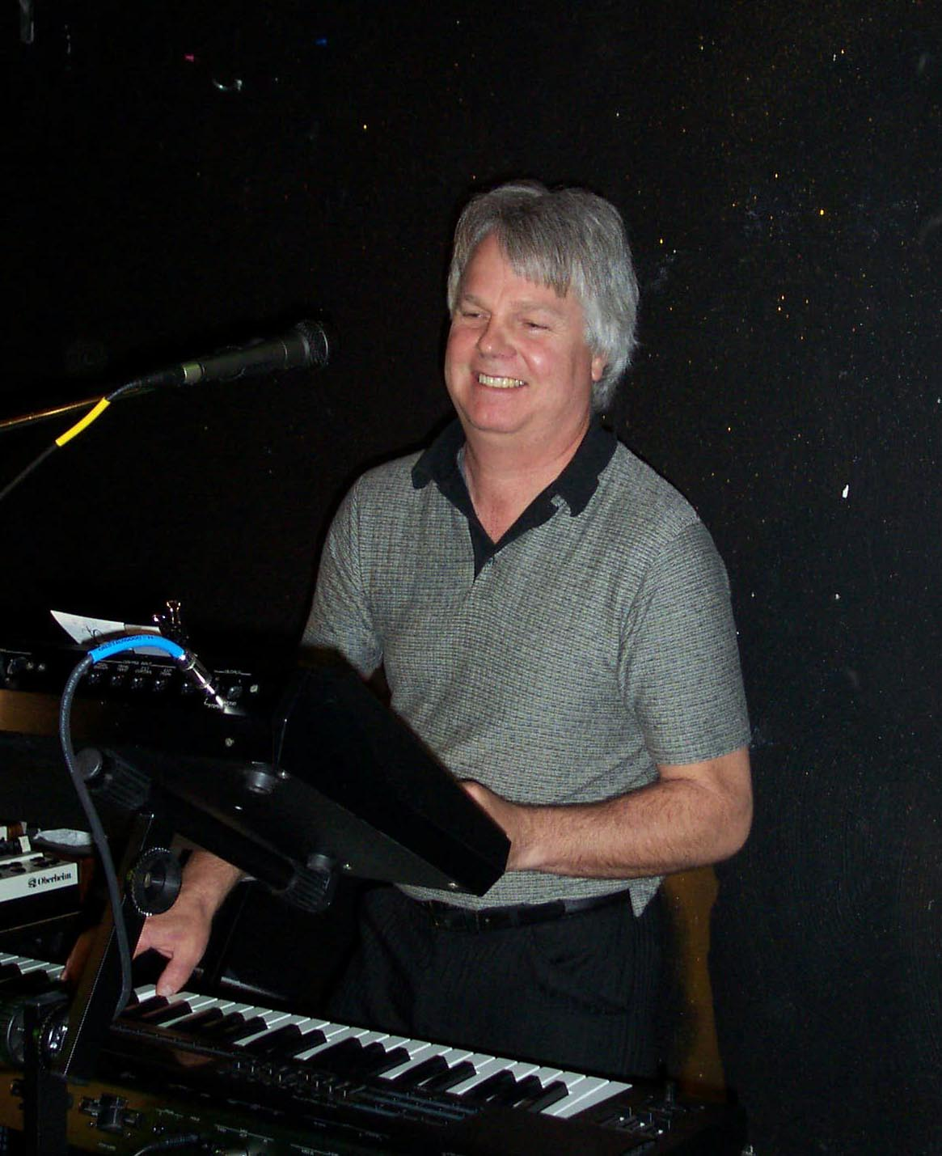
Dennis Bussell – Keyboards

Dennis began playing piano at the age of ten. He studied classical and popular music for six years and jazz improvisation for two years. Dennis studied music and choir at Everett Community College and continued on to Western Washington University where he later joined a rock band as the keyboardist. Since the early 1970’s, Dennis has performed with various local bands performing rock to blues, including three years with the Penguins.

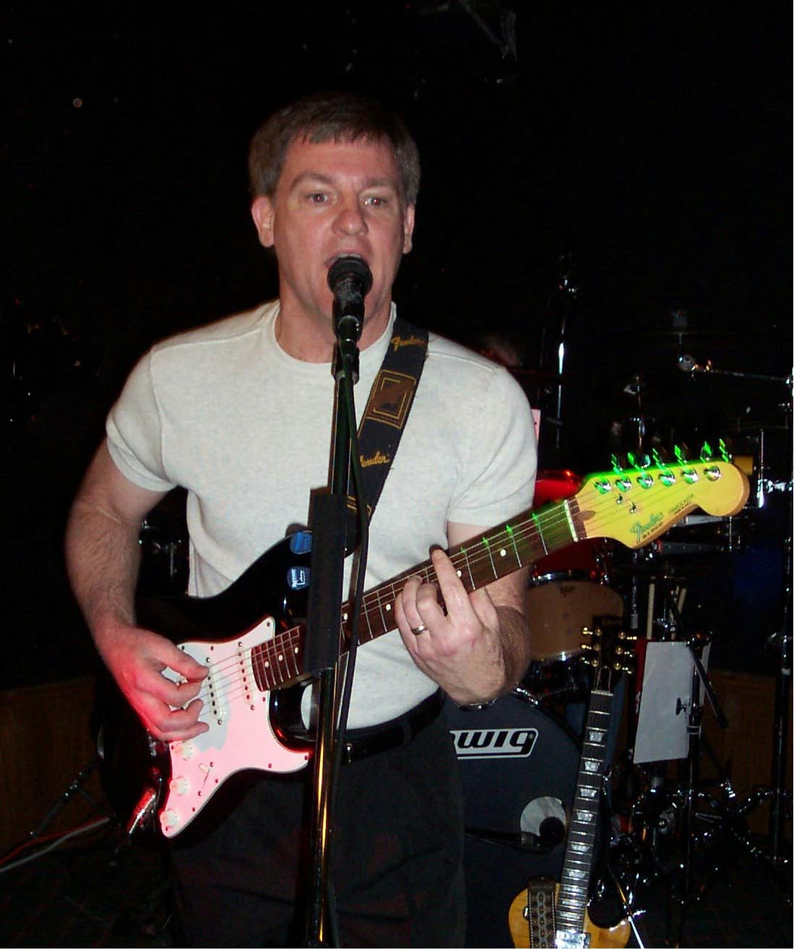
Mike Messick – Guitar, Vocals
Mike began playing guitar in the Washington DC/Baltimore area in 1967. He played for a local top 40 band throughout the Maryland/Pennsylvania/Deleware area, opening up for local record artists touring the East Coast. Mike then spent four years playing guitar and keyboards with a 7 piece “Horn Band”, playing soul, funk and R+B. After ten years of moving coast to coast, he rejoined a classic rock group in the Philadelphia area performing for several years before moving to the Northwest in 1997. Mike is one of the founding members of the band.

Tom Peters – Bass
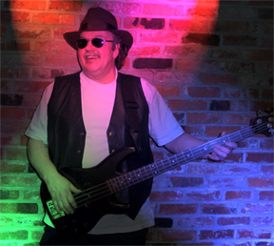
Tom started playing bass in the early 1960’s on theSouth side of Chicago where he was influenced by Motown and Chicago Blues. Tom moved to Seattle in the id 60’s where he started playing in bands influenced by the Beatles and playing in popular bands such as Equinox and the Prisoners. Tom had a break in music while serving Uncle Sam, but picked up where he left off ofter discharge playing in several local bands through the 80’s and 90’s until linking up with Mirage.

Bill Taylor – Drums, Vocals
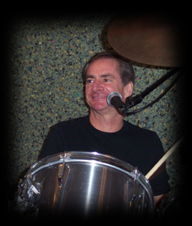
Bill started out in Minneapolis as founding member of The Uptown Boys show band. Since then he has accumulated over 20 years of professional experience playing a wide range of styles including rock, jazz, R+B and orchestral work. After moving to Seattle, he formed All the Rage and has played in a number pf bands in the Puget Sound area before hooking up with Mirage.

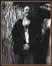
Scott “Junior” Adams – Sax, vocals
He began playing clubs too young, and often had to sneak in the back door when the bouncer wasn’t looking, leap on stage right before the band started, and run out the door as soon as they were done. After 6 months, he was finally tired of the lying and sneaking around, and went to Seoul, South Korea, where they don’t care how old you are, as long as you can afford the drinks.
When he returned to Seattle, he looked around for jazz gigs, and realized that since he wasn’t 60 years old (and never would be), there weren’t any available. He started playing with the following bands and musicians (not necessarily in this order): Seattle Blues Revue, Apollo Creed, The Roger Rogers Band, Nicole Fournier, Everyday People, Souler Energy, Full Circle, Molasses, Hip City, the Little Kings, Emerald City Jazz Orchestra and Doctor Funk
Scott has amazing luck, and has been recommended to play with a number of genuinely famous people, like Ann Wilson from Heart. He plays in her band occasionally to this day. Ann was good enough to invite him to play with her at a fundraiser for President Clinton, and Scott got to jam with Jerry Cantrell from Alice in Chains and Steve Bishop from Los Lobos, and even got his picture taken with the leader of the free world! Amazingly, he passed the Secret Service’s background check. He also was invited to play with Slash from Guns ‘n Roses. Slash’s background check was not nearly as thorough.
Scott is an outstanding soloist and has been known to extend solos for long periods of time so the rest of the horns can go get a drink.
                                                                                                            Kevin Seeley -Trumpet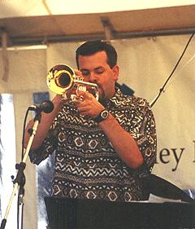
Kevin adds the sizzling lead trumpet sound to the Bad Ass Brass Horn section. He has been involved in the Seattle Music scene since 1990 playing full time with many top local bands and in many musical styles. He has spent time with Molasses, the Seattle Blues Revue, Andy O, the Urban Horns and the Emerald City Jazz Orchestra, Seattle Funk and Soul Revue, The Horndogs among others. Kevin has also added his trumpet work to many other bands as a top call sub including Big Dog Revue, The Marvelles, Dance Factory, Mambo 9, The Tocats, Groove Mob, Michael Crain Band, Roadside Attraction, Jet City Jazz Band, Kings of Swing and the Fred Radke Orchestra. He is also the leader and lead trumpet player for the Emerald City Jazz Orchestra.

Over the years, Kevin has had the good fortune to share the stage with many different well known groups including, the Brand New Heavies, Blind Melon, Cherry Poppin’ Daddies, members of Pearl Jam, Barrington Levy, Burning Spear, Eek-A-Mouse, members of BRAD, Bobby Shew and others.

Vic Anderson - Trombone

Vic originally from the Seattle area, graduated from Central Washington University in 1988 with a Music Ed degree and then moved to Los Angeles California. While in California Vic paid some hard dues on the Holand America Cruise Line in 1989 and then settled in North Hollywood and Northridge for the next twelve years. In LA, Vic played and recorded with a variety of artists covering a wide range of styles and repetoire. Vic accompanied and backed artists including Mel Torme, Rich Little, Poncho Sanchez, Celia Cruz, and Joan Rivers. He has recorded with the Garcia Brothers, Quervo Productions and played on a variety of jingles and independant movie soundtracks.

Vic continued his formal music education at the University of Southern California graduating in 1995 with a Masters in Jazz Studies. He also holds a Masters in Educational Administration from California State University at Northridge and currently works for the Seattle Public Schools as a Middle School Administrator. Since returning to the Seattle area, Vic has been in high demand as a performer, and currently plays lead trombone with the Emerald City Jazz Orchestra.

number of bands around the Puget Sound area.

