
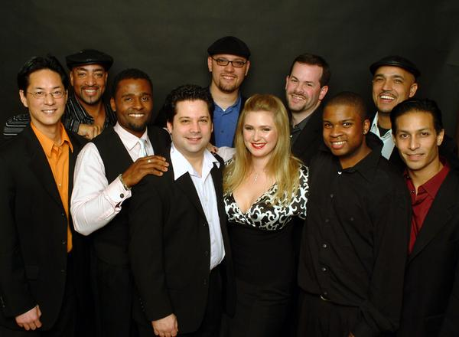
Tired of Celebration? Bored with Mustang Sally?
We play the hits the others don't.
Most dance bands are all the same, playing the same songs, night after night, over and over again.
Players Club has a vast repertoire, spanning four decades of music, constantly expanding our list of songs, you won't hear the same old songs at every show.
Players Club is a unique combination of seasoned professional musicians, interspersed with young, fresh talent. Between them are decades of performances, tours, and recordings, stretching across all genres of music. This level of talent and experience guarantees the listener that not only do we have the intensity and energy to put on a great show, but the talent to back it up! With three versatile lead singers and a sizzling three piece horn section, Players Club is one of the most exciting bands in the Pacific Northwest.
Players Club is also capable of starting your event off with a Jazz trio during a reception or solo guitar or piano during dinner. Whatever your needs are, Players Club does our best to accommodate you.
We hope you decide to check us out,


Link for audio files:
http://www.myspace.com/playersclubmusic

Partial Song list:
Song Title | Artist
One, Two Three | Gloria Estefan
After The Love Is Gone | Earth, Wind, & Fire
Ain’t Too Proud To Beg | The Temptations
Ain’t No Mountain | Marvin Gaye & Tammi Terrell
Ain’t No Stoppin’ Us Now | McFaddin & Whitehead
Another Star | Stevie Wonder
Baby Be Mine | Michael Jackson
Baby I Love You | Aretha Franklin
Backstabbers | The O'Jays
Bad Girls | Donna Sommers
Brick House | Commodores
Born Under A Bad Sign | Etta James
Call Me | Blondie
Can’t Hide Love | Earth, Wind, & Fire
Chain Of Fools | Aretha Franklin
Conga | Gloria Estefan
Dark End Of The Street | James Carr
Disco Dazz | The Dazz Band
Don’t Leave Me This Way | Thelma Houston
Don’t Stop Till You Get Enough | Michael Jackson
Express Yourself | Madonna
Fantastic Voyage | Lakeside
Fantasy | Earth, Wind, & Fire
Feelin’ Alright | Joe Cocker
Ffun | Confunction
Fire | Jimi Hendrix
Getaway | Earth, Wind, & Fire
Give It To Me Baby | Rick James
Good Times | Chic
Got To be Real | Cheryl Lynn
Hard To Handle | Black Crowes
Hold On, I’m Coming | Sam & Dave
Holiday | Madonna
Hot Stuff | Donna Sommers
I Can’t Wait | Nu Shooz
I Need Your Lovin’ | Teena Marie
I Wish | Stevie Wonder
In My House | The Mary Jane Girls
In The Stone | Earth, Wind, & Fire
Into The Groove | Madonna
I’m Your Boogie Man | K.C. & The Sunshine Band
It Feels Good | Tony, Toni, Tone
Jungle Boogie | Kool & The Gang
Kalimba | Earth, Wind, & Fire
Let It Whip | The Dazz Band
Let’s Groove | Earth, Wind, & Fire
Let’s Stay Together | Al Green
Love Machine | Smokey Robinson & The Miracles
Love Light In Flight | Stevie Wonder
Love Train | The O'Jays
Lover Girl | Teena Marie
Maria Maria | Santana
Mary Jane | Rick James
Material Girl | Madonna
My Baby Wrote Me A Letter | Eva Cassidy
My Cherie Amour | Stevie Wonder
My Girl | The Temptations
Outstanding | The Gap Band
Oye Como Va | Santana
P.Y.T. | Michael Jackson
Reasons | Earth, Wind, & Fire
Rhythm Is Gonna Get You | Gloria Estefan
Rock That | Earth, Wind, & Fire
Rock With You | Michael Jackson
September | Earth, Wind, & Fire
Serpentine Fire | Earth, Wind, & Fire
Sex Machine | James Brown
Shake Your Body | Michael Jackson
Shake Your Booty | K.C. & The Sunshine Band
Shake Your Groove Thing | Peaches & Herb
She’s A Bad Mamma Jamma | Carl Carlton
Shining Star | Earth, Wind, & Fire
Signed, Sealed, & Delivered | Stevie Wonder
Smooth Operator | Sade
Son Of A Preacher Man | Dusty Springfield
Sophisticated Lady | Natalie Cole
Step In The Name Of Love | R. Kelly
Summertime | Will Smith
Sweet Thing | Chaka Khan
Take Your Higher | Sly & The Family Stone
Take Your Time | The S.O.S. Band
Thriller | Michael Jackson
Uptight | Stevie Wonder
Watchtower | Jimi Hendrix
Walking On Sunshine | Katrina & The Waves
We Want The Funk | Parliament
What’s Going On | Marvin Gaye
What You Won’t Do For Love | Bobby Caldwell
Your Precious Love | Marvin Gaye & Tammi Terrell
You And I (Rick James) | Rick James
You And I (Stevie Wonder) | Stevie Wonder



Kevin Seeley
21424 NE 165th St
Woodinville, WA. 98077
206-465-1988

